Here are the *frontend.py*and *backend.py*scripts in OOP style. To execute this program, you should execute the *frontend.py* file.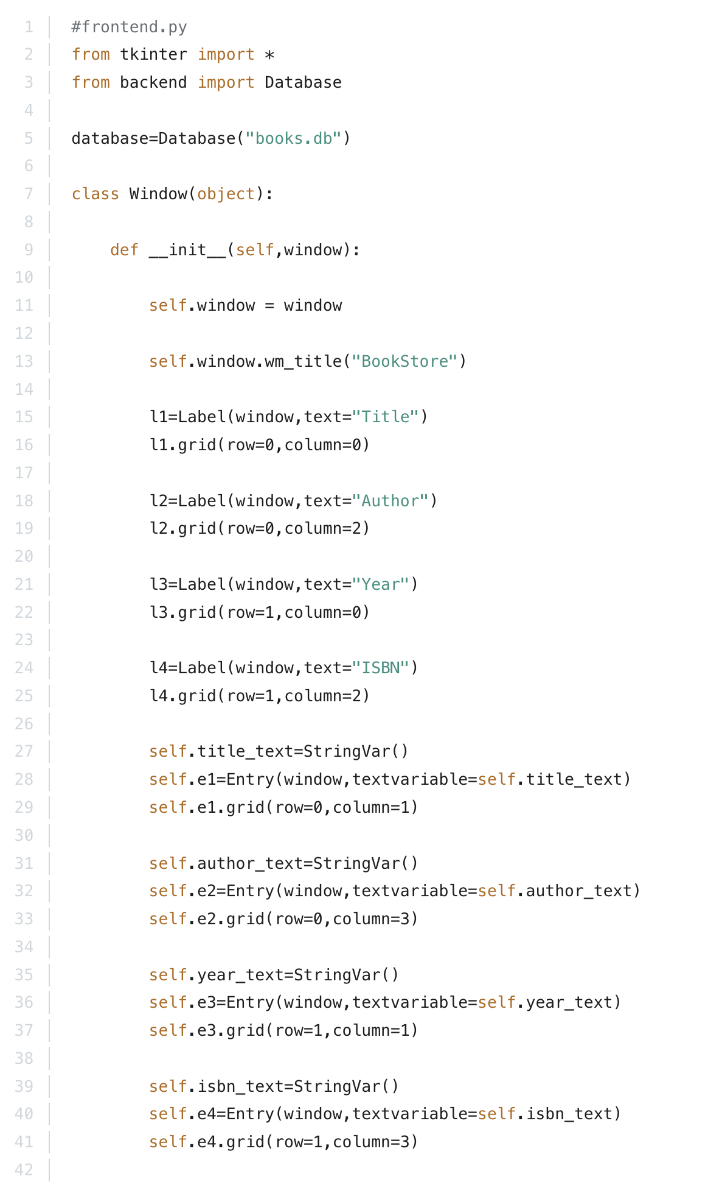

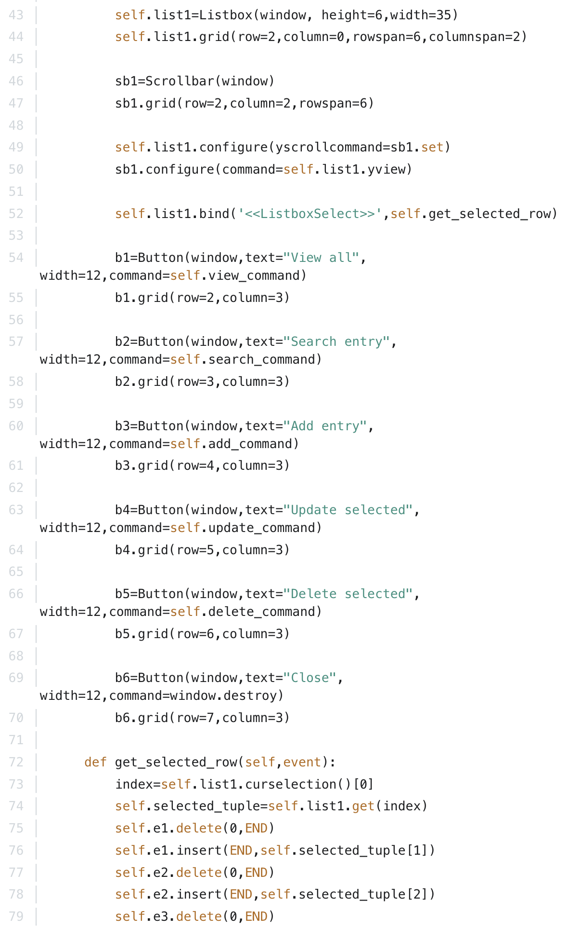

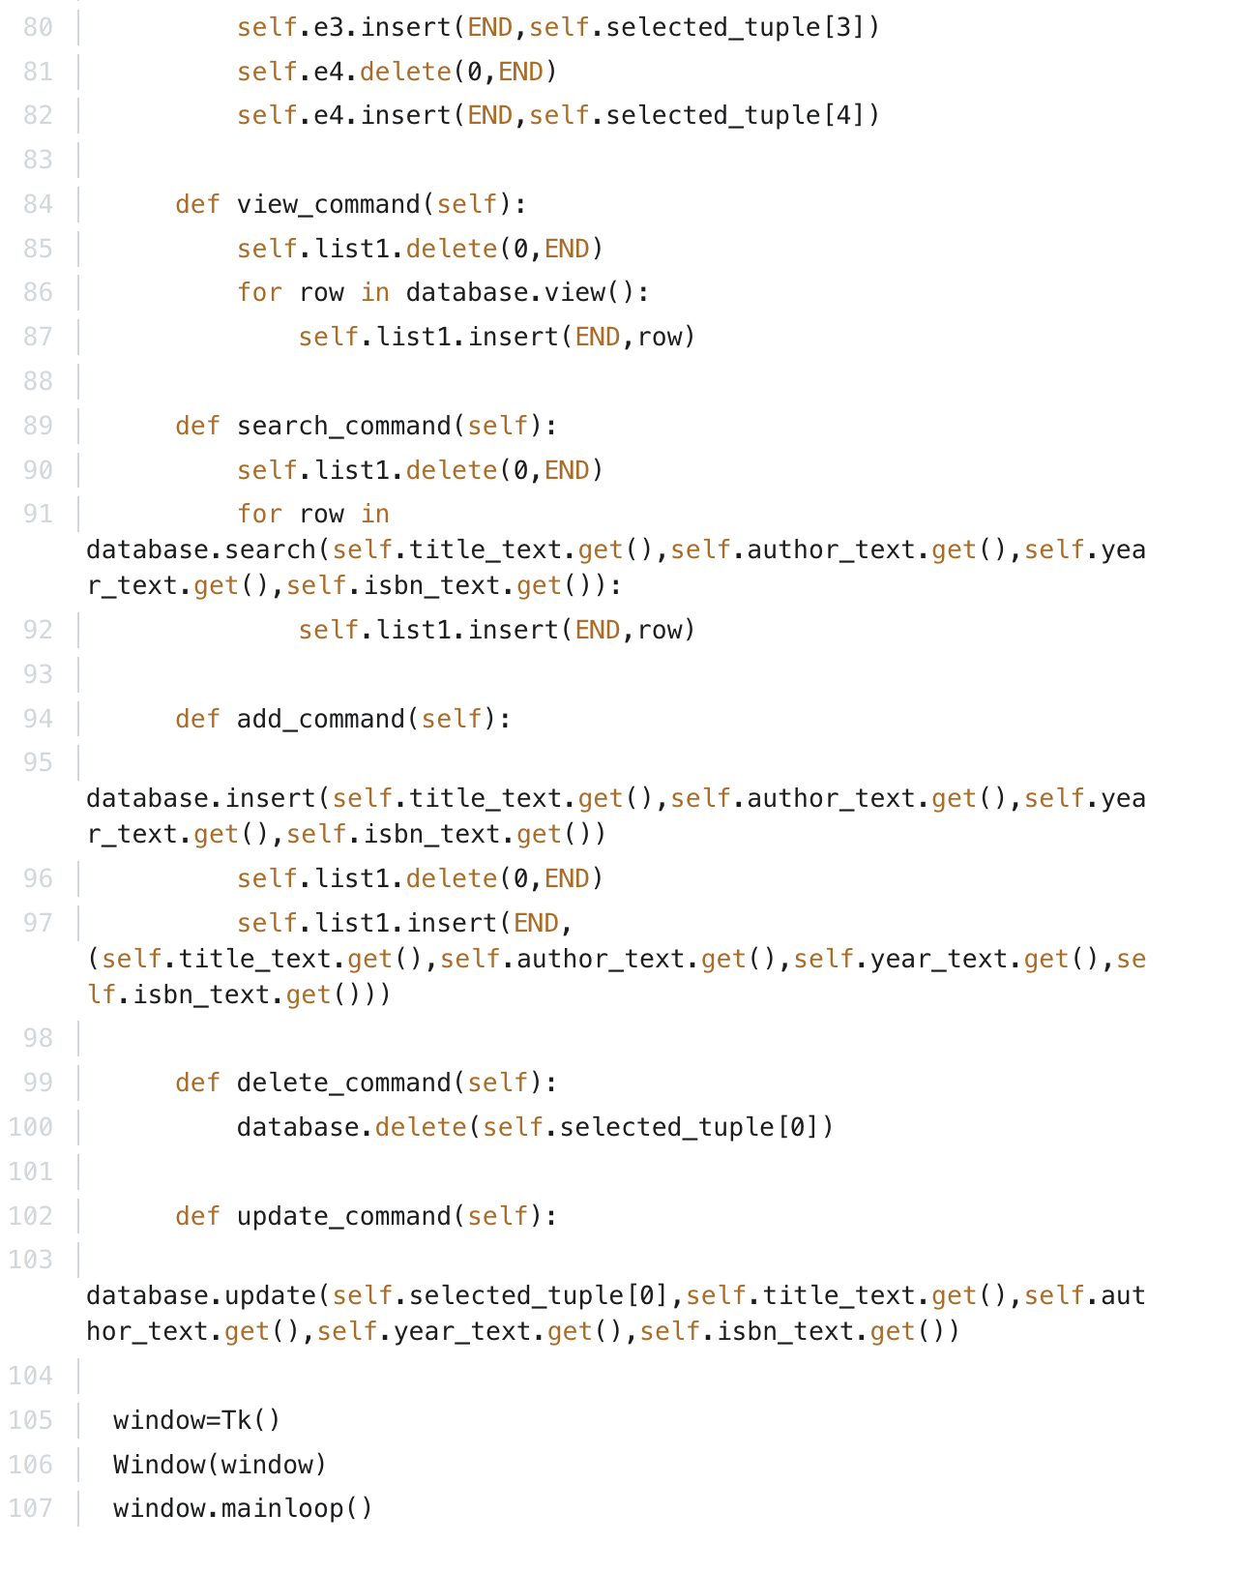

And below, you will also find the backend.py script in OOP:

